JUnit Testing Exercises

Exercise 1: Setting Up Junit

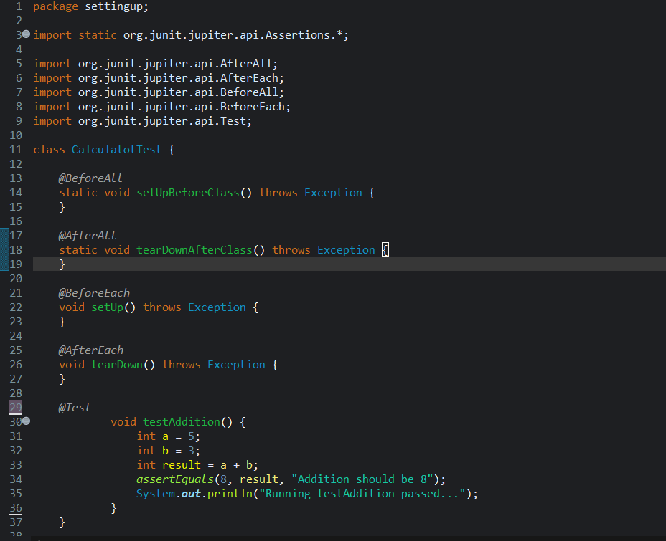

OUTPUT

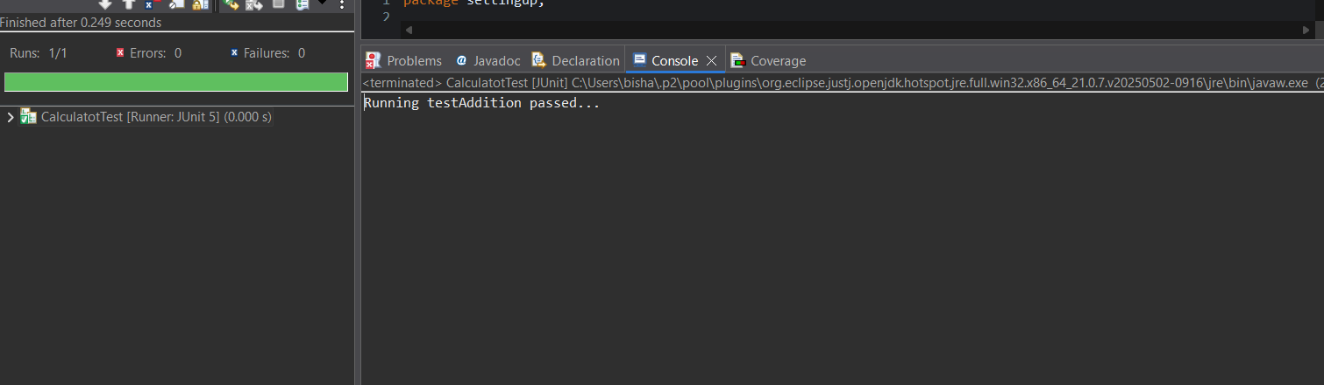

Exercise 3: Assertions in Junit

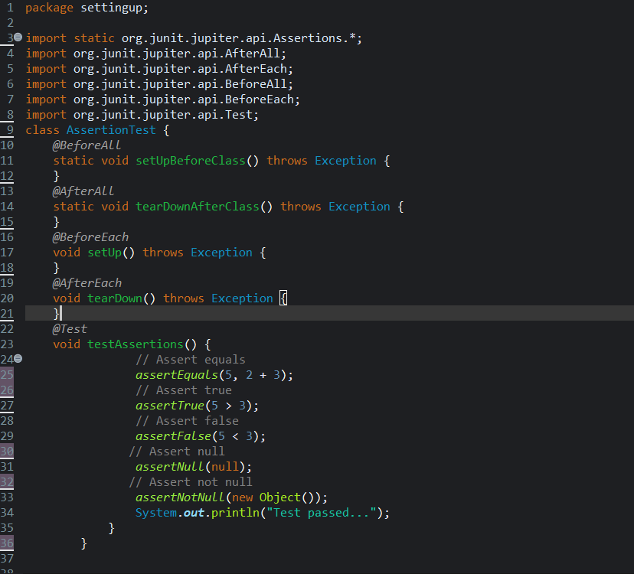

OUTPUT

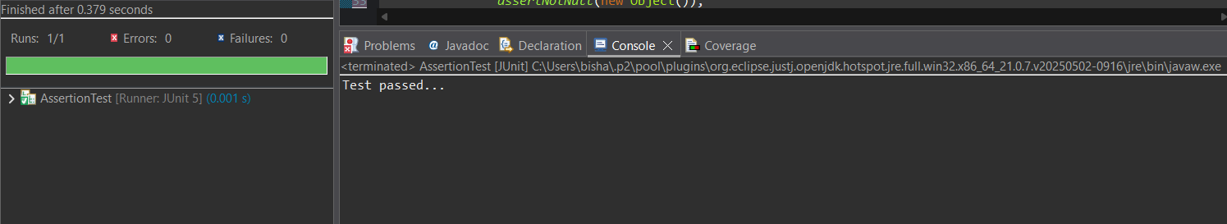

Exercise 4: Arrange-Act-Assert (AAA) Pattern, Test Fixtures, Setup and Teardown Methods in Junit

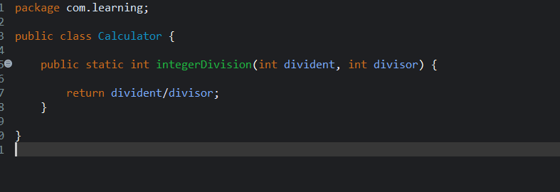

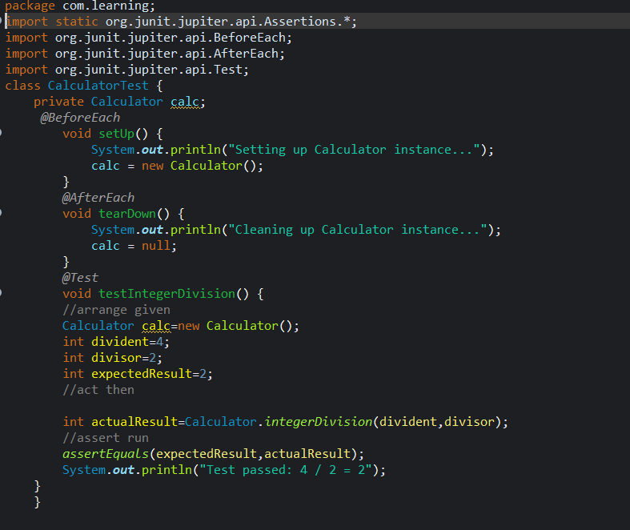

OUTPUT

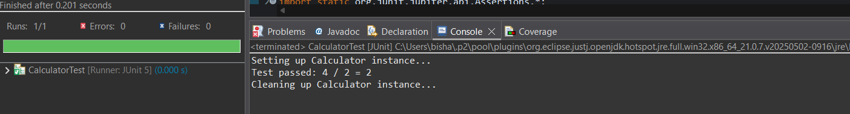

Mockito Hands-On Exercises

Exercise 1: Mocking and Stubbing

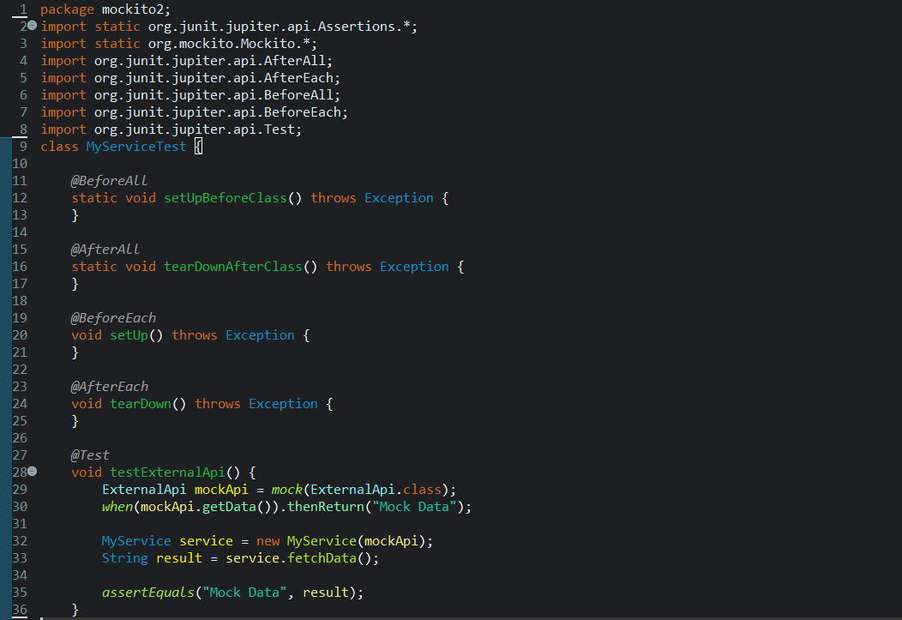

OUTPUT

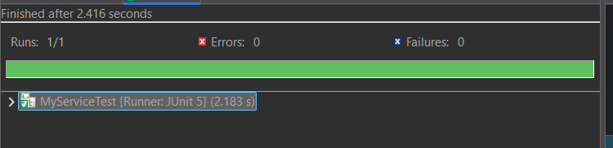

Exercise 2: Verifying Interactions

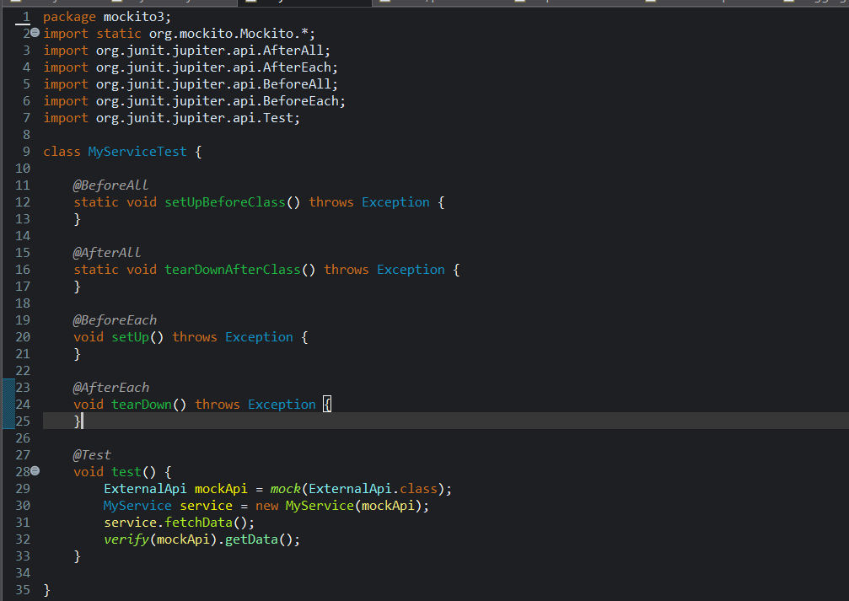

OUTPUT

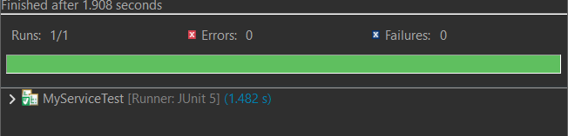

Logging using SLF4J

Exercise 1: Logging Error Messages and Warning Levels

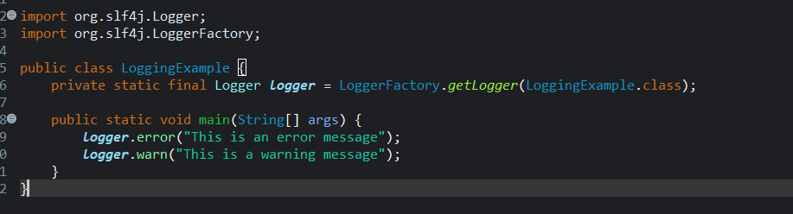

OUTPUT

